**Name: Sneha Roy , Section : B , Roll : 42**

**Enrollment No.: 12024006015099**

**Assignment - 2**

1. Write a C program to add, subtract, multiply, and divide two integers using a user-defined type function with a return type.

**Input:**

#include <stdio.h>

int add (int a, int b){

  return a + b;

}

int subtract (int a, int b){

  return a - b;

}

int multiply (int a, int b){

  return a * b;

}

int divide (int a, int b){

  return (float)a / b;

}

int main() {

  int a, b, choice;

  do {

    printf("\n\nChoose an Operation: \n");

    printf("Press 1 to add\n");

    printf("Press 2 to subtract\n");

    printf("Press 3 to multiply\n");

    printf("Press 4 to divide\n");

    printf("Press 5 to exit\n");

    scanf("%d", &choice);

    printf("\n\nEnter two integers : ");

    scanf("%d %d", &a, &b);

    switch (choice){

    case 1:

      printf("Sum :  %d", add(a,b));

      break;

    case 2:

      printf("Difference :  %d", subtract(a,b));

      break;

    case 3:

      printf("Product :  %d", multiply(a,b));

      break;

    case 4:

      if(b != 0)printf("Quotient :  %d", divide(a,b));

      else printf("Error: Division by Zero!");

      break;

    case 5:

      printf("Exit");

      break;

    default: printf("Invalid Choice!!");

    }

  } while (choice != 5);

  return 0;

}

**Output:**

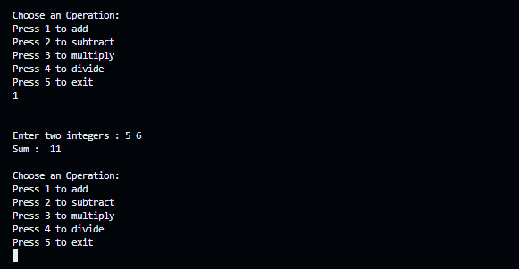

2. Write a C program to calculate the sum of the first 20 natural numbers using a recursive function.

**Input:**

#include<stdio.h>

int sum(int n){

  if(n == 0 || n == 1) return n;

 else return n + sum(n - 1);

}

int main(){

  printf("Result : %d", sum(20));

  return 0;

}

**Output:**



3. Write a C program to generate a Fibonacci series using a recursive function.

**Input:**

#include<stdio.h>

int Fibonacci(int term){

  if(term == 0 || term == 1) return term;

  else return Fibonacci(term - 1) + Fibonacci(term - 2);

}

int main(){

  int term;

  printf("Enter the term : ");

  scanf("%d", &term);

  printf("Result : " );

  for(int i = 0; i < term; i++) printf("%d , ", Fibonacci(i));

  return 0;

}

**Output:**



4. Write a C program to swap two integers using call-by-value and call-by-reference methods of passing arguments to a function.

**Input:**

#include<stdio.h>

void swapPassByValue(int a, int b){

  int temp = a;

  a = b;

  b = temp;

  printf("Inside the 'swapPassByValue' function =>  a : %d ,  b: %d \n" , a ,b);

}

void swapPassByReference(int *a, int *b){

  int temp = *a;

  *a = *b;

  *b = temp;

  printf("\n\nInside the 'swapPassByReference' function =>  a : %d ,  b: %d \n" , *a ,*b);

}

int main(){

  int a, b;

  printf("Enter the value of a : ");

  scanf("%d", &a);

  printf("Enter the value of b : ");

  scanf("%d", &b);

  //Pass By value

  swapPassByValue(a, b);

  printf("\n  outside 'swapPassByValue' function a : %d ,  b: %d " , a ,b);  //no change

  //Pass by Reference

  swapPassByReference(&a, &b);

  printf("\n  outside 'swapPassByReference' function a : %d ,  b: %d " , a ,b);  //no change

  return 0;

}

**Output:**

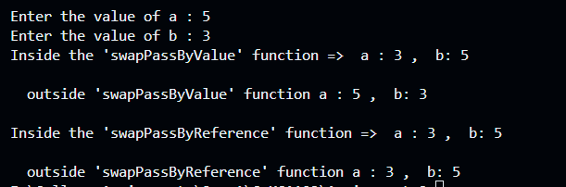

5. Write a C program to find the sum of the digits of the number using a recursive function.

**Input:**

#include<stdio.h>

int sumOfDigit(int n){

  if(n == 0) return 0;

 else return (n% 10 ) + sumOfDigit(n / 10);

}

int main(){

  int n;

  printf("Enter a number : ");

  scanf("%d", &n);

  printf("Result : %d", sumOfDigit(n));

  return 0;

}

**Output:**



6. Write a C program to read an integer number and print the reverse of that number using recursion.

**Input:**

#include<stdio.h>

void reverse(int n){

  if(n == 0) return ;

  else {

    printf("%d", n%10);

    return reverse(n / 10);

  }

}

int main(){

  int n;

  printf("Enter a number : ");

  scanf("%d", &n);

  printf("Result : ");

  reverse(n);

  return 0;

}

**Output:**



7. Using functions, write a C program to find the maximum and minimum between two numbers.

**Input:**

#include<stdio.h>

int max(int a, int b){

 if(a > b) return a;

 else return b;

}

int min(int a, int b){

 if(a < b) return a;

 else return b;

}

int main(){

  int a , b;

  printf("Enter two numbers : ");

  scanf("%d %d", &a, &b);

  printf("Maximum : %d\n", max(a,b));

  printf("Minimum : %d", min(a,b));

  return 0;

}

**Output:**

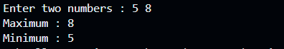

8. Write a C program to check whether a number is even or odd using functions.

**Input:**

#include<stdio.h>

char* OddEven(int n){

  if(n == 0) return "Zero";

  else if( n % 2 == 0 ) return "Even";

  else return "Odd";

}

int main(){

  int num;

  printf("Enter a number : ");

  scanf("%d", &num);

  printf("The number %d is :  %s", num, OddEven(num));

  return 0;

}

**Output:**



9. Write a C program to check whether a number is a prime, Armstrong, or Perfect number using functions.

**Input:**

#include<stdio.h>

void isArmstrong (int num){

  int n, digitCount = 0, remainder, sum = 0;

  n = num;

    while (n != 0) {

        n = n / 10;

        digitCount++;

    }

    n = num;

    while (n != 0) {

        remainder = n % 10;

        int power = 1;

        for (int i = 0; i < digitCount; i++) {

            power *= remainder;

        }

        sum += power;

        n /= 10;

    }

    if( num == sum) printf("%d is an Armstrong number.\n\n", num);

    else printf("%d is an Armstrong number.\n\n", num);

}

void isPrime (int n){

  for (int i = 2; i < n; i++) {

    if(n % i == 0) {

      printf("%d is not a Prime number.\n\n" , n);

      return;

    }

  }

  if(n == 1) printf("1 is not a Prime Number.\n\n");

  else printf("%d is a Prime Number.\n\n", n);

}

void isPrefect(int n){

  int sum = 0;

  for(int i = 1; i < n; i++){

    if(n % i == 0){

      sum += i;

    }

  }

  if(sum == n) printf("%d is a Prefect Number.\n\n", n);

  else printf("%d is not a Prefect Number.\n\n", n);

}

int main(){

  int n;

  printf("Enter a number : ");

  scanf("%d", &n);

  printf("Result : \n");

  isArmstrong(n);

  isPrime(n);

  isPrefect(n);

  return 0;

}

**Output:**

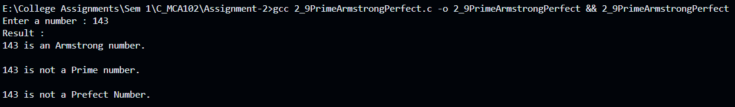

10. Write a C program to find the power of any number using recursion.

**Input:**

#include<stdio.h>

int power(int base, int pow){

  if(pow == 1) return base;

  return base * power(base, pow - 1);

}

int main(){

  int base, pow;

  printf ("Enter base and Exponent : ");

  scanf("%d %d", &base, &pow);

  printf("Result: %d", power(base, pow));

  return 0;

}

**Output:**

